MR16 LED Comet Spot Lights

These light bulbs are made of US (CREE® XLamp® XPE high power LED) and Taiwan led chips and can be used indoor Art galleries Cosmetic counters, Restaurants, Hotels, Exhibitions, Residential applications and Easy to retrofit virtually any lamps that are designed with the MR 16 lamp holders.

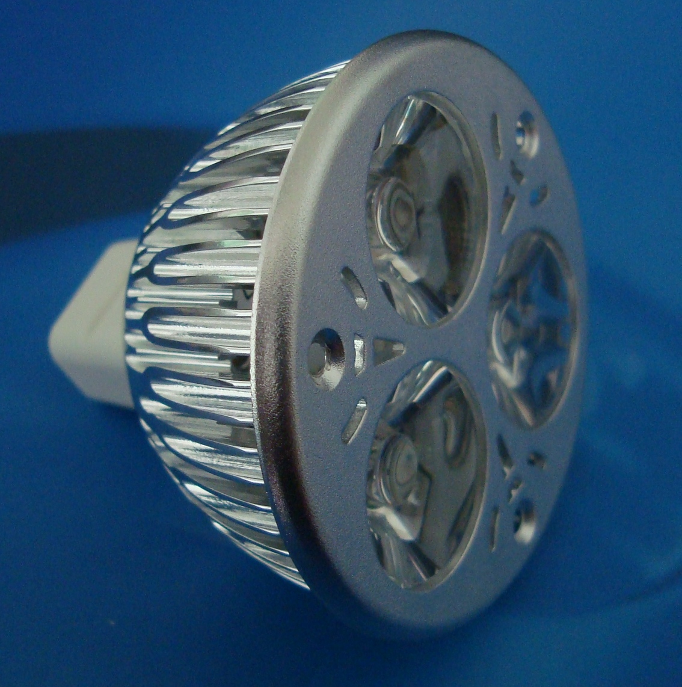

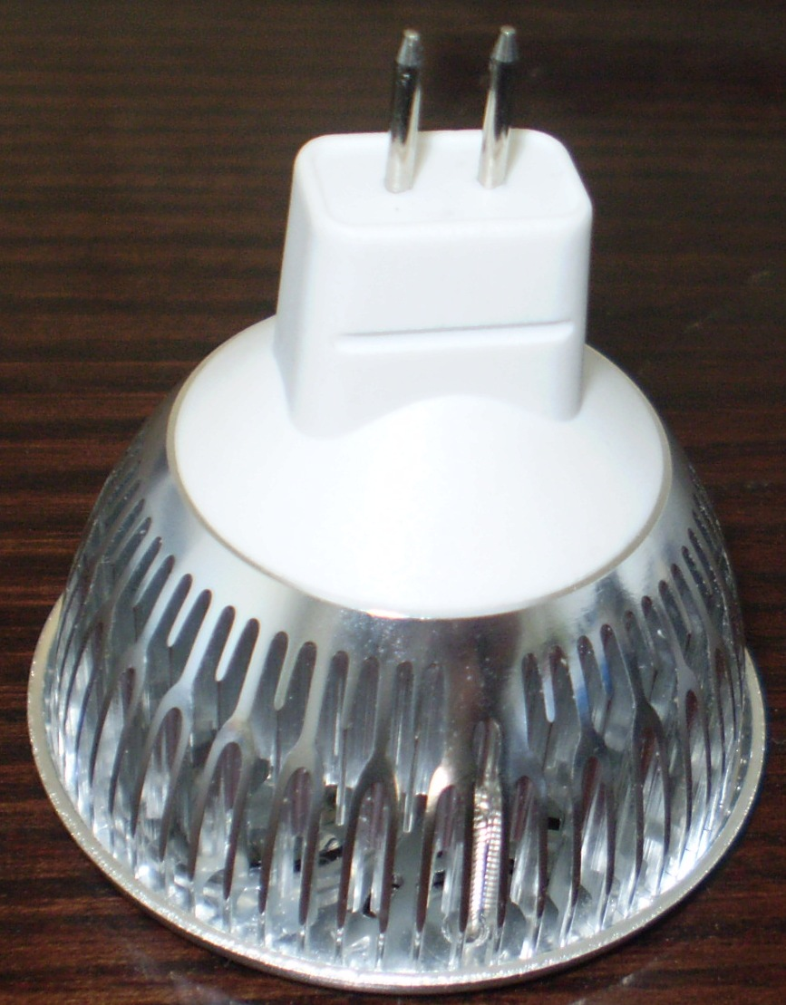
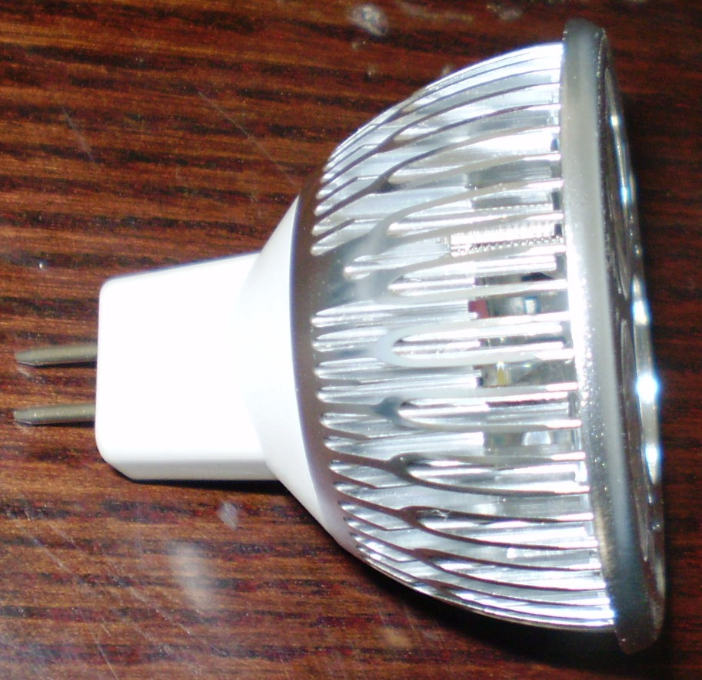

MR16 Comet 3
It is widely used in museums, art galleries, cosmetic hotels, restaurants, exhibit and so on. It's popular in place where UV or IR radiation is undesirable.
Main Features
1. Base Type: MR16
2. Input Voltage: 12V AC/DC with reversed polarity protect
3. Power: 3W
4. Light Source: CREE 3 x 1W high power LED
5. Color: cool white or warm white. Other colors are also available.
6. Luminous:
6.1 Warm White: 210 lm
6.2 White: 320 lm
7. Body Temperature: <60°C
8. Beam Angle: 30° or 60°
9. No mercury, no electromagnetic emission, and no UV and IR radiation
10.Certification: CE and RoHS
Applications
1. Art galleries
2. Cosmetic counters
3. Restaurants
4. Hotels
5. Exhibit
6. Residential applications
7. Counters where UV or IR radiation is undesirable
8. General Lighting
Custom specifications are also available. Please contact us.
Model: MR16 Comets 3

Why CREE?

Please read this to understand why we are using CREE® XLamp® XPE LED original package chips.

The CREE's XLamp® XPE LED is leading the LED lighting revolution with its unprecedented lighting-class brightness, efficacy, lifetime and quality of light. These lighting-class features enable the XLamp® XPE LED to replace many traditional light sources and save money with energy-efficient light and long lifetimes. Cree's advantage is in the materials they use. CREE® LEDs combine highly efficient InGaN materials with proprietary G•SIC® substrates to deliver superior price/performance for high-intensity LEDs. Typical features of CREE® LEDs include
- A single wire-bond connection
- Low forward voltage
- Exceptional thinness
- Low heat generation
- High electrostatic discharge (ESD) tolerance/resistance
- Long life
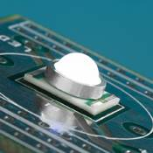
For our customers, CREE® LEDs provide critical benefits, such as
- Super-bright light from little power
- Easy fit into tight places
- Simple thermal management
- Long product life / High Reliabilty

